**ECE637 Lab report 5**

**Eigen-decomposition of Images**

**Name:Chengzhang Zhong**

**Section 2 .Multivariate Gaussian Distributions and Whitening**

**Part 1. Generating Gaussian random vectors**

**1. The plot for W**

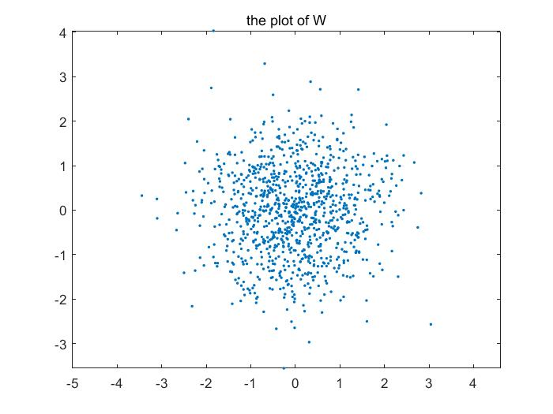

**2. The plot for $\tilde{X}$**

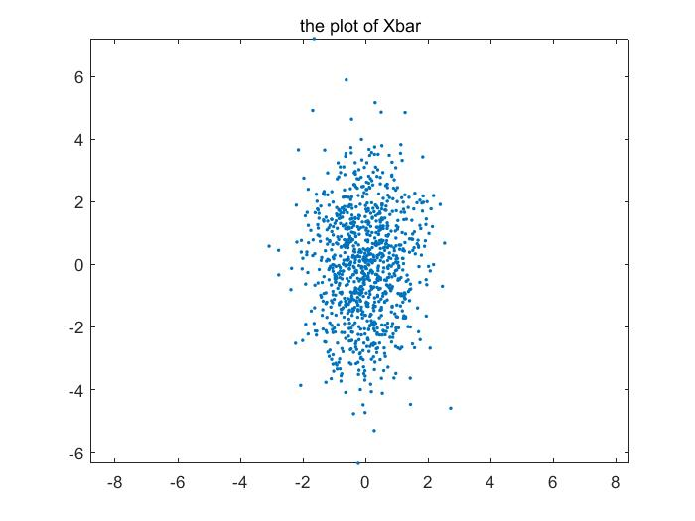

**3. The plot for X.**

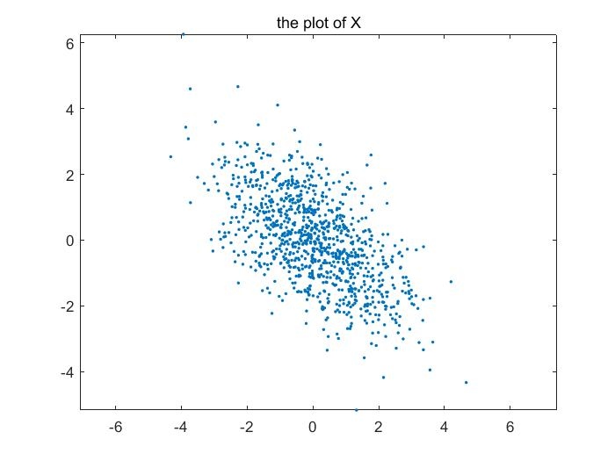

**Part 2. Covariance Estimation and Whitening**

**Theoretical value of the covariance matrix **



**A numerical listing of your covariance estimate **



**A numerical listing of the covariance estimate **



1.The plot for

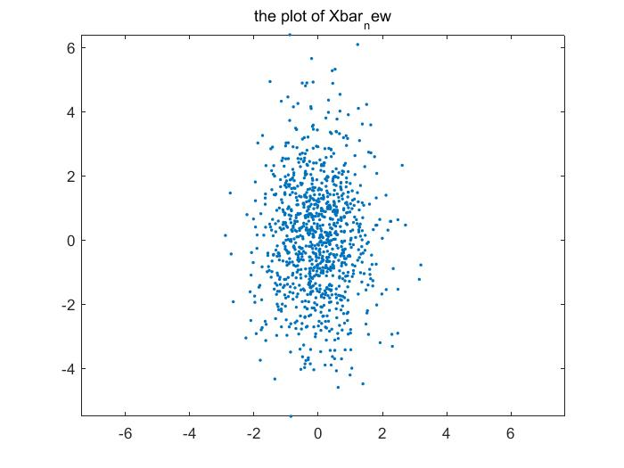

2. The plot for W

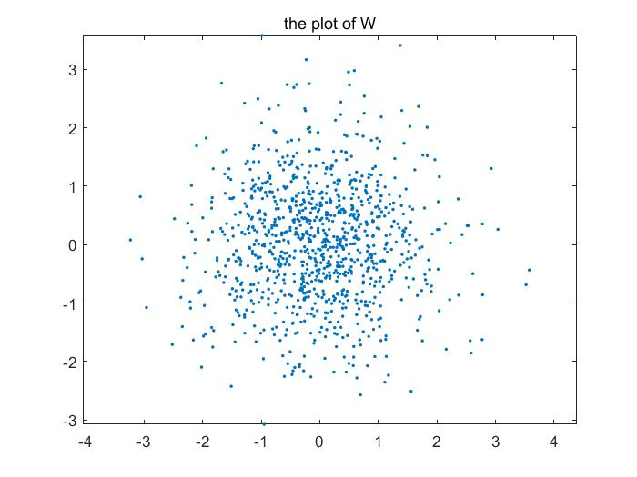

**Session 4. Eigenimages, PCA, and Data Reduction**

**1. The first 12 eigen images**

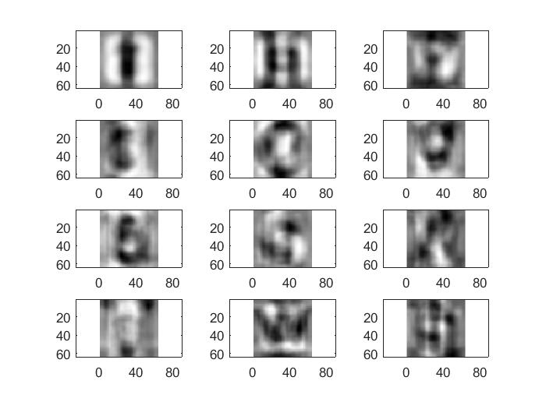

**2. plots of projection coefficients vs. eigenvector number**

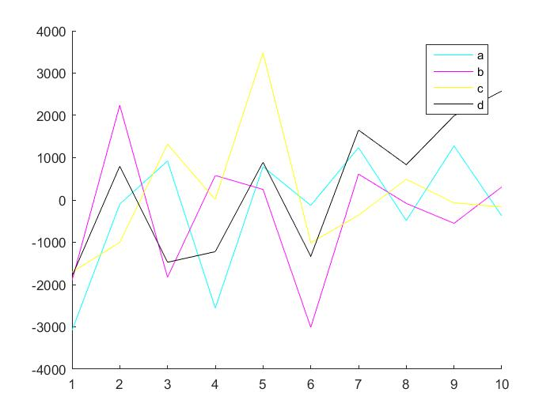

**3.** **the original image, and the 6 resynthesized versions**

**Original:**

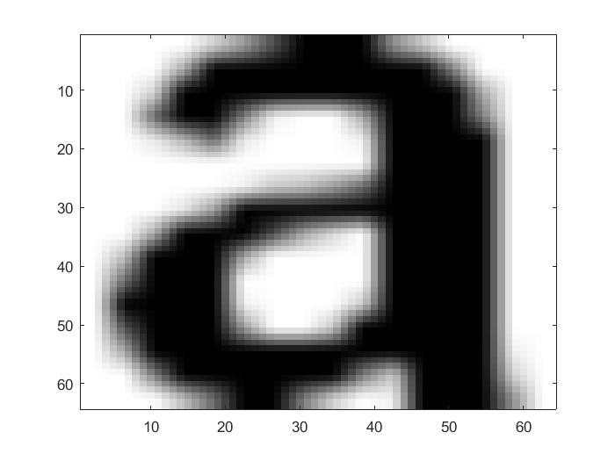

**6 resynthesized versions:**

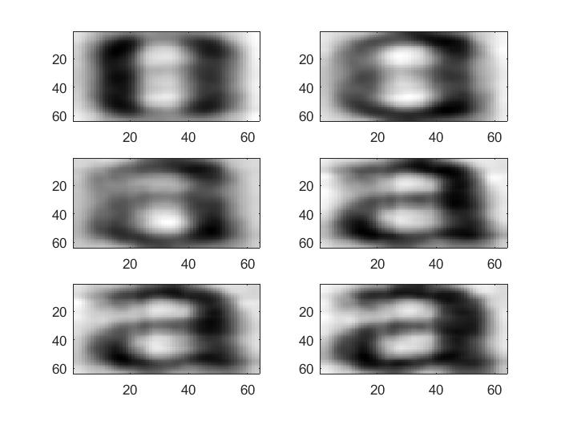

**Section 5. Classification and PCA**

1. The original $B_{k}$

***input sequence:* abcdefghijklmnopqrstuvwxyz**

***Output sequence:* abcaefghiykimvoearstavwxvz**

***Result: There exists mistakes for d,j,i,n,p,q,u,y, totally 8 mistakes.***

2. For

***input sequence:* abcdefghijklmnopqrstuvwxyz**

***Output sequence:* abcdefghljklmnopqrstuvwxvz**

***Result: There exists mistakes for i,y totally 2 mistakes.***

3. For

***input sequence:* abcdefghijklmnopqrstuvwxyz**

***Output sequence:* abcdefqhijklmnopqrstuvwxvz**

***Result: There exists mistakes for g,y totally 2 mistakes.***

4. For

***input sequence:* abcdefghijklmnopqrstuvwxyz**

***Output sequence:* abcdetghijklmnopqrstuvwxvz**

***Result: There exists mistakes for f,y totally 2 mistakes.***

5. For

***input sequence:* abcdefghijklmnopqrstuvwxyz**

***Output sequence:* abcdetqhijklmnopqrstuvwxvz**

***Result: There exists mistakes for f,g,y totally 3 mistakes.***

**Q&A:**

**1. Which of the above classifiers worked the best in this experiment?**

The second, third and fourth classifier works the same in the experiment.

**2. In constraining the covariance, what is the trade off between the accuracy of the data model and the accuracy of the estimates?**

In the case of this experiment, the constraint will lower the accuracy of this data model, but it turns out we received a better result, which means a better accuracy of the estimates. But one should be aware that once the constrain goes beyond a threshold, the accuracy of the estimate will also be reduced.